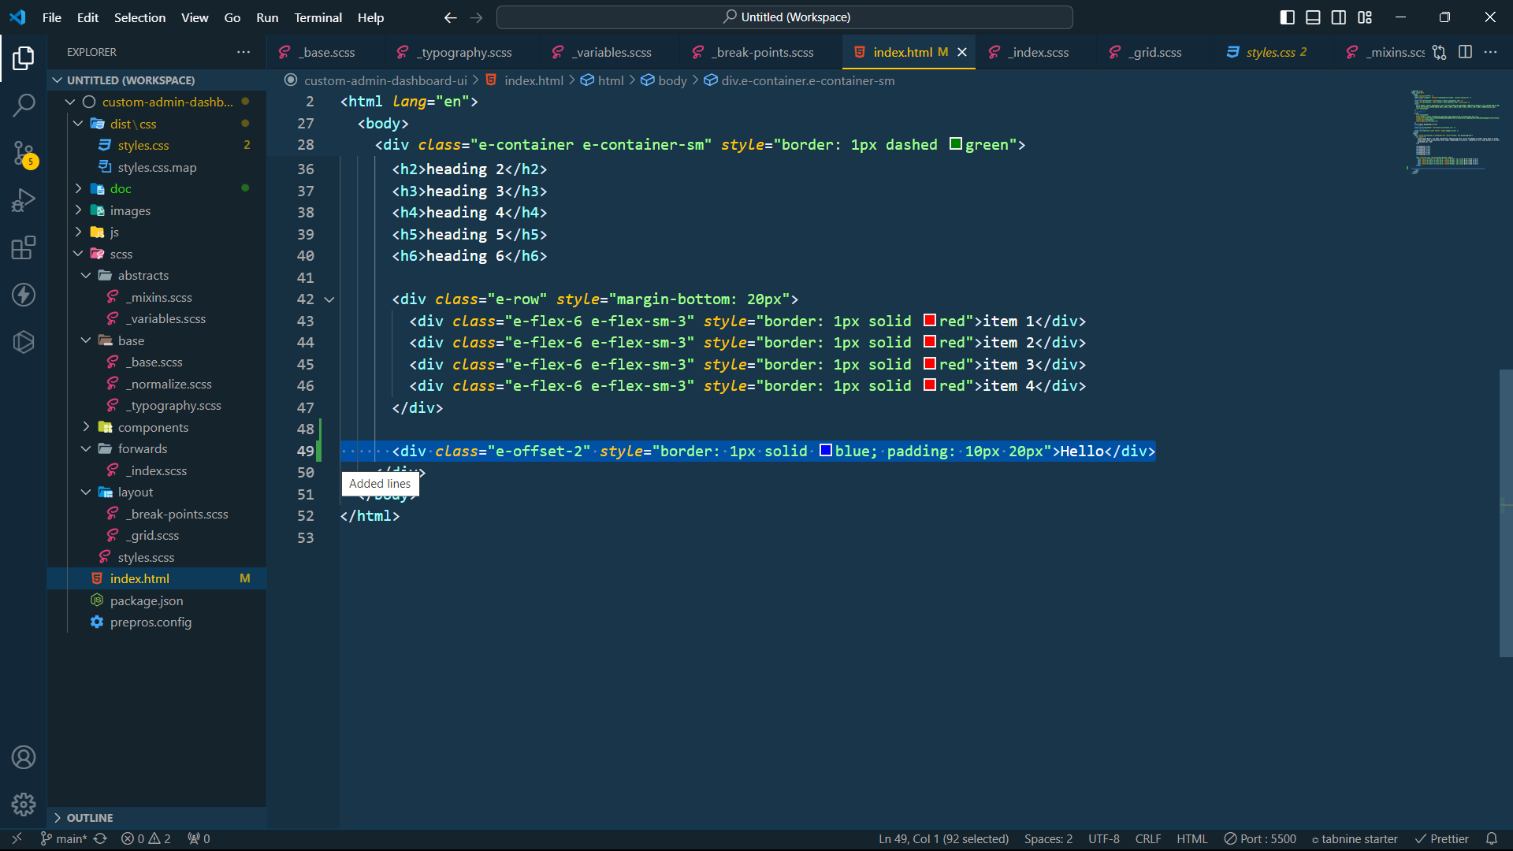

* $total-cols: 12
* Có responsive không

* Nếu có **responsive** thì lặp map **containers** lấy **key** và **value**

